EXPERIMENT:7: Create a simple cloud software application for Students Attendance System using any Cloud Service Provider to demonstrate SaaS include the necessary fields such as name of the students, course, present , Absent, course attendance, OD request, grade, attendance percentage, etC

STEP:1 CRAETE A APPLICATION FOR STUDENT DETAILS FOR THE ATTENDANCE.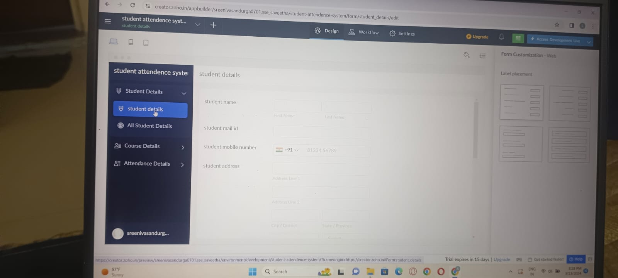

STEP:2 CREATE A APPLICATION FORM FOR COUSRE DETAILS.

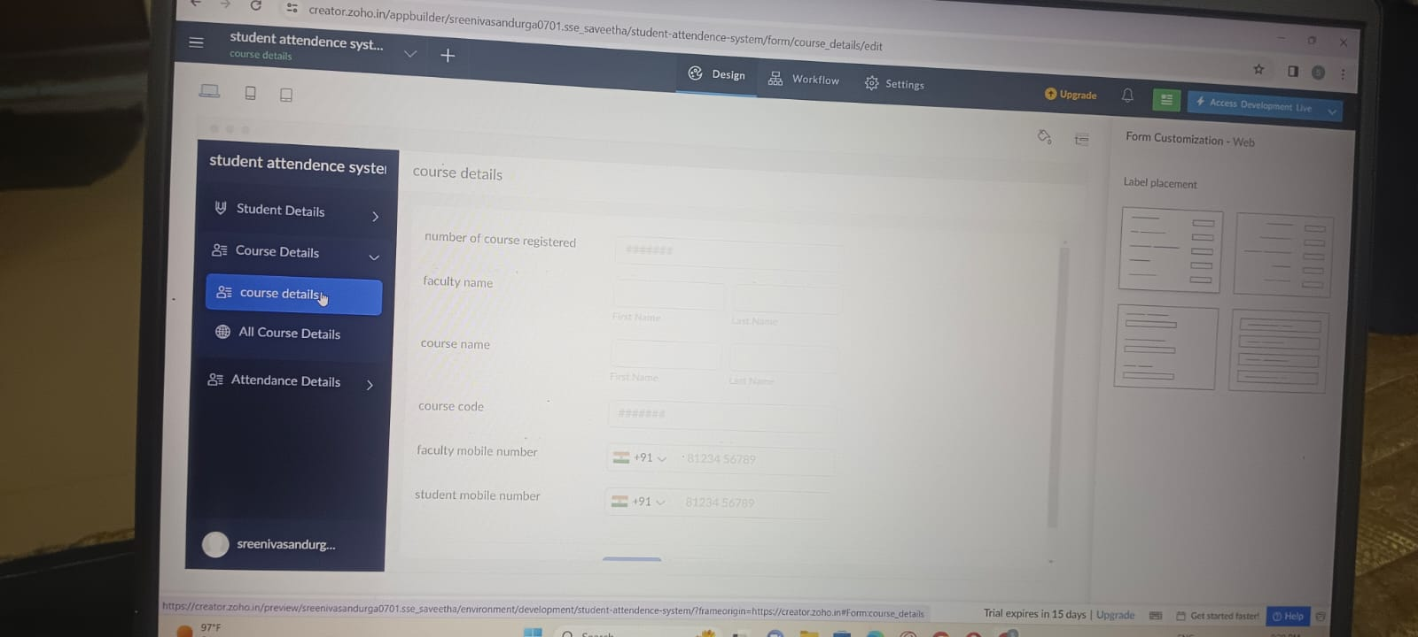

STEP:3: CREATE A APPLICATION FORM STUDENT ATTENDANCE DETAILS:

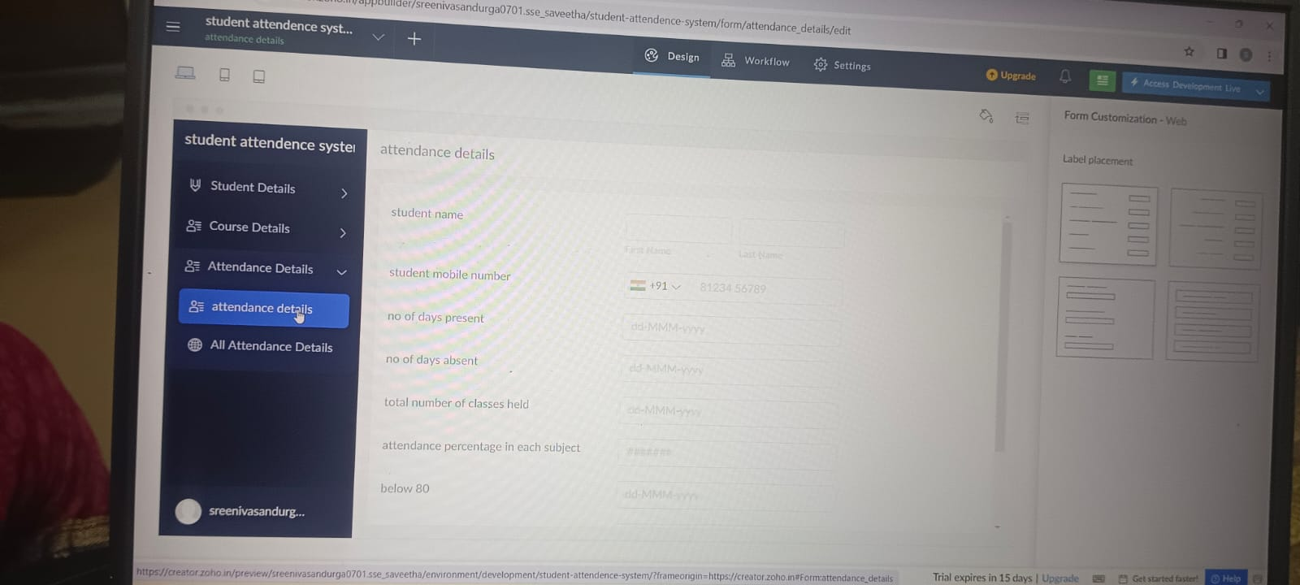

STEP:4 CREATE A APLICATION FORM STUDENT ATTENDANCE RESULT: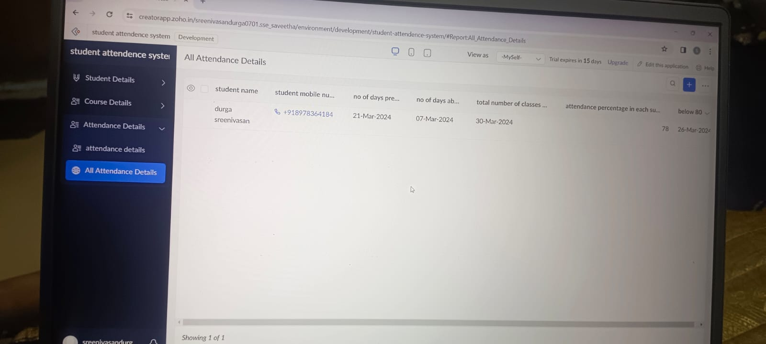

RESULT: THUS, THE PROGRAM FOR THE STUDENT ATTENDANCE SYSTEM HAS BEEN EXCEUTED SUCCESSFULLY.